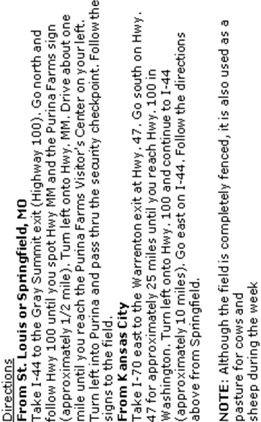

Run For Fun
Christine Allen
322 Tooley Branch Road
Westmoreland, TN 37186
DATED MATERIAL

Licensed by the American Kennel Club
PREMIUM LIST
Event #2014697203 & Event #2014697204
Junior Courser Test | Qualified Courser Test

Making History – 1st JC/QC Held by the PPPA

THURSDAY & SATURDAY
September 11, 2014
September 13, 2014
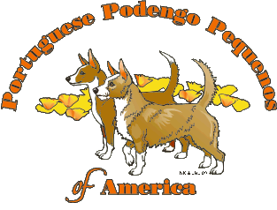
Portuguese Podengo Pequenos ONLY

PURINA FARMS; 200 Checkboard Dr; Gray Summit, MO

Early Entries close 6 p.m. on
Wednesday, August 27th, 2014

Entry Fees
Early entry for J.C.’s and Q.C.’s …………… | $15 per hound
Day of trial entry …………..………….… | $20 per hound

Phone, fax, and email entries will NOT be accepted.
Entries may be acknowledged by email.

Send entries to: Christine Allen;
322 Tooley Branch Rd; Westmoreland, TN 37186

LICENSED BY THE AMERICAN KENNEL CLUB

Permission has been granted by the American Kennel Club for
the holding of this event under AKC Rules and Regulations.
James Crowley, Secretary
Portuguese Podengo Pequenos of America
Officers
President Suzanne Faria; suzannefaria@att.net
Vice President Dr. John Fitzpatrick
Secretary Jean Evanoff; jaevanoff@yahoo.com; P.O. Box 816; N. Sioux City, S.D 57049
Treasurer Penny Schroeder
Board Mary Ellen Barragan; Sandra Gillen; Carol Sowders; Alice Mirestes;
Stacy Faw

AKC Field Committee

Chairman: Alice Mirestes; 2123 Pine Woods Rd; Springdale, AR 72762 ; alice@ihoundz.com 479-466-2590

Secretary: Christine Allen; 322 Tooley Branch Rd; Westmoreland, TN 37186
run4funtn@gmail.com 615/406-8220

Other Committee Members: Suzanne Faria, Stacy Faw, Susan Faw, Jody Smith, Alice Mirestes and any other club member that is in attendance at the time.

Lure Operator:  Photographer: | Alan Salm - Thursday Scott Green - Saturday  Penny McNeil

Judges and Assignments
Thursday -- Joe Stewart
AKC Judges #: 96801
12140 Oak Ridge Drive
Rolla, MO 65401
Email: khur65401@yahoo.com

Saturday -- Karen Catt
AKC Judges #: 80505
RR#2
New Liskeard, On 0N{0J1P0
Email: icy_cold_ibizans@yahoo.com

EVENT | HOURS | DAY OF TRIAL ENTRIES CLOSE | ROLLING INSPECTION Begins | START RUNNING
Thursday
JC Test Judge:  Joe Stewart | 7:30 a.m. until completion | 8:00 a.m. | 8:15 a.m. | Immediately after the JC/QC test for Ibizan Hounds
QC Test Judge:  Joe Stewart | 7:30 a.m. until completion | 8:00 a.m. | 8:15 a.m | immediately after the conclusion of JC Test
Saturday
JC Test Judge:  Karen Catt | 12:00 pm until Completion | 12:00 pm | 1:00 pm | Immediately after the ASFA Trial for Ibizan Hounds
QC Test Judge:  Karen Catt | 12:00 pm until Completion | 12:00 pm | 1:00 pm | immediately after the conclusion of JC Test

Ribbons & Prizes
JC Tests: 1st leg: Green Flat Ribbon
JC/QC titles earned: Green Rosette
All entrants will receive a stuffed toy, one per dog/per day

Eligible Breed & Registry
Only Portuguese Podengo Pequenos, that are one year of age or older, that have been registered with The American Kennel Club, or part of an AKC-registered litter, or otherwise, if whelped outside of the United States of America and owned by a resident of the USA, or of a country with a foreign registry organization whose pedigrees are acceptable for AKC registration and is registered with that registry, or that have been granted an Indefinite Listing Privilege (ILP), are eligible to participate in lure coursing tests and trials. Hounds may not be entered as “registration pending” or “ILP Pending.” Breed disqualifications apply

TESTS OFFERED

Junior Courser (JC) Test Offered
Junior Courser: Open to eligible Portuguese Podengo Pequenos. A hound running alone must receive a certification from a Judge on one date, and a second certification from a different Judge at a later date, with each Judge stating that the hound completed a (minimum) 600-yard course with a minimum of 4 turns. The hound must complete the entire course with enthusiasm and without interruption. Ribbons (Dark Green) will be awarded to all hounds that successfully complete the AKC Junior Courser Test.
Qualifying Courser (QC) Offered
Qualifying Courser: Open to eligible Portuguese Podengo Pequenos. The qualifying hound will run with another hound, completing a (minimum) 600-yard course with a minimum of 5 turns. The qualifying hound must complete the entire course with enthusiasm, without interruption, and without coursing, interfering with, or aggressing on the other hound. Owner of qualifying dog must provide or arrange for a hound of like running style for their hound to run with in this test.

Veterinarian on Call:
Pacific Animal Hospital; 450 Flier Dr.; Pacific, MO 63069
636-257-2100
24-hour emergency services available

Conditions of Entry
• All entries must be one year of age or older on the day of the trial.
• Hounds not present at the time of roll call will be scratched after a 5 minute grace period and no refund will be given.
• • Bitches in season and lame hounds will be excused. Entries will be refunded. These are the only reasons that Early Entries will be refunded after the pre-entry closing date.
• There will be a minimum $30 returned check charge.
• Hounds will be checked for breed disqualifications. Spayed and neutered hounds are eligible to participate. Monorchid and cryptorchid hounds are ineligible to participate.
• Owners of hounds entered for a QC run are responsible for providing and/or arranging for the additional hound to run with.
• A $5.00 fine will be assessed for any loose hound on the field that is not competing in the course in progress.
• Battery powered, continuous loop equipment will be used. Lures consist of white plastic.
• Back-up equipment will be available.
• PPPA reserves the right to alter course due to field and/or weather conditions on the day of the trial.
• Course will be reversed for any QC that also ran the JC test.
- Although the field is completely fenced, it is also used as a pasture for cows and sheep during the week
- Adequate shade and cool/drinking water should be provided by the participants.
.• Any person may, upon reasonable complaint, be asked to leave the grounds by the Field Committee. Children MUST be under control of their parents or guardians at all times.

Only the Lure Operator, Huntmaster, Judges and Handlers of the hounds running in the course in progress will be permitted near the lure machine.

Notes for the weekend:

  - Make sure to bring shade and water for your hounds

  - Your hound no longer needs a JC to enter a trial but the JC still appears as a title after your hounds name if they earn it.

  - Make sure to pay attention to the running order and to the paddock master – if your hound is ready and waiting, when it’s his turn to run, the trial goes smoother for everyone. Any hound that is more than five minutes late in getting to the line for their course may be excused from competition for the day as per AKC rules.

  - There will be a port-a-john on site.

  - Please park in the parking lot located prior to the bridge

  - If you are new to the sport, grab someone and ask questions! We’re always happy to help “newbies” learn the ropes!

  - Anybody exhibiting unsportsmanlike behavior will be excused from the field and may be subject to further disciplinary action.

  - No cigarette smoking on or near the field.

  - DO NOT TURN DOGS LOOSE IN ANY OF THE FENCED AREAS

ADDITIONAL NOTES ABOUT QC RUNS

- You are responsible for finding a hound of like running style to run your QC hound with. You cannot expect to run your hound for a QC without arranging for another hound to help certify yours.

- You will be handed a form to fill out at roll call. You must fill this out and RETURN it to the Field Trial Secretary BEFORE the QC runs begin – THIS IS IMPORTANT!

- Once your hound has completed its QC and the judge has come off the field, please see the Field Trial Secretary to retrieve your certification form. You will need to attach this (or a copy of it) to your hound’s first official entry into the Open or Open Veteran stake at your first trial.

- The JC test is no longer required AT ALL to enter the open stake and, in fact, a hound may have a JC title but without the QC (or other stated requirements) a hound MAY NOT enter the Open or Open Veteran stake at a trial.

- If you have any questions about this – please contact the Field Trial Secretary

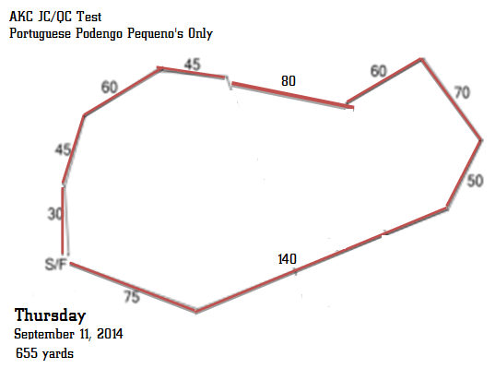

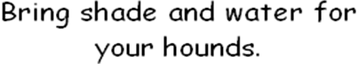

(Reversed for QC’s that ran JC’s)

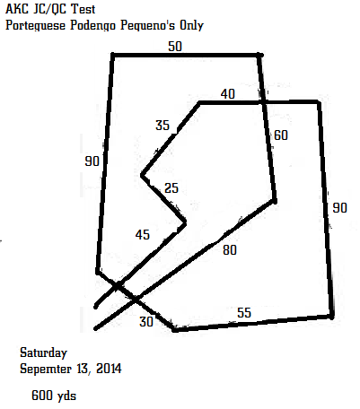

Courses may be modified due to weather or field conditions as deemed necessary by the Trial Chairman of IHCUS.

Accommodations:

Holiday Inn Six Flags 4901 Allenton Road, Eureka, MO (636) 938-6661 HOST HOTEL

The Diamond Inn I-44 and Hwy. 100, Gray Summit, MO (636) 742-3501

EconoLodge Eureka 1725 W. 5th St., Eureka, MO (636)938-5348 or (800)251-1962

Super 8 Eureka 1733 W. 5th St., Eureka, MO (636) 938-4368, or (800) 800-8000

Budget Lodging 866 S. Outer Rd., St. Clair, MO (636) 629-1000 or (800) 958-4354

Super 8 St. Clair 1010 S Outer Rd, St. Clair, MO (636)629-8080 or (800)800-8000

Drury Inn 1088 S. Highway Dr., Fenton, MO (636) 343-7822 or (800) 378-7946

Pear Tree Inn 100 S. Highway Dr., Fenton, MO (636- 343-8820 or (800) 378-7946

KOA St. Louis West 18475 Old Highway 66, Eureka, MO (636) 257-3018

PLEASE VERIFY CURRENT PET POLICIES WHEN MAKING RESERVATIONS

THERE IS ABSOLUTELY NO CAMPING PERMITTED AT THE TRIAL SITE

Camping is available at the Purina Show grounds.

Forms available on IHCUS website:

(http://www.ihcus.org/specialty/2014-national-specialty).

Other Campgrounds That May Accept Pets

Jellystone Park Campground …. 636‐938‐5925

KOA Campground ……………… 636‐257‐3018

Pin Oak Creek …........................ 636‐451‐5656

Robertsville State Park …………. 636‐257‐3788


official entry form for lure coursing

Date: Sept 11, 2014

Club name: PPP'S OF AMERICA

(IMPORTANT: carefully read instructions on bottom before filling out)
breed  Portuguese Podengo Pequeno |  | sex: Male  Female |  |  | Event Number
Test: JC QC TRIAL: SINGLES OPEN SPECIALS VETERAN
Location Gray Summit, Mo / Purina Farms |  |  | Event Type (Check one) Test Trial
akc® name (Include AKC titles only) |  |  |  |  |  | call name of dog
akc® no. ilp  pal foreign reg. no | (Enter number below) |  |  | date of birth  place of birth (List Country)
breeder
sire
dam
actual owners
owners address |  |  | new address
city, state, zip + 4 , -
AKC Rules, Regulations, Policies and Guidelines are available on the American Kennel Club website:www.akc.org
AGREEMENT
I certify that I am the actual owner of the dog, or that I am the duly authorized agent of the actual owner whose name I have entered above. In consideration of the acceptance of this entry, I (we) agree to abide by the rules and regulations of The American Kennel Club in effect at the time of this event, and any additional rules and regulations appearing in the premium list of this event and entry form and any decision made in accord with them. I (we) agree that the club holding this event has the right to refuse this entry for cause which the club shall deem sufficient. In consideration of the acceptance of this entry and of the holding of this event and of the opportunity to have the dog judged and to win prizes, ribbons, or trophies, I (we) agree to hold the AKC, the event-giving club, their members, directors, governors, officers, agents, superintendents or event secretary and the owner and/or lessor of the premises and any provider of services that are necessary to hold this event and any employees or volunteers of the aforementioned parties, and any AKC approved judge, judging at this event, harmless from any claim for loss or injury which may be alleged to have been caused directly or indirectly to any person or thing by the act of this dog while in or about the event premises or grounds or near any entrance thereto, and I (we) personally assume all responsibility and liability for any such claim; and I (we) further agree to hold the aforementioned parties harmless from any claim for loss, injury or damage to this dog. Additionally, I (we) hereby assume the sole responsibility for and agree to indemnify, defend and save the aforementioned parties harmless from any and all loss and expense (including legal fees) by reason of the liability imposed by law upon any of the fore mentioned parties for damage because of bodily injuries, including death at any time resulting there from, sustained by any person or persons, including myself (ourselves), or on account of damage to property, arising out of or in consequence of my (our) participation in this event, however such, injuries, death or property damage may be caused, and whether or not the same may have been caused or may be alleged to have been caused by the negligence of the aforementioned parties or any of their employees, agents, or any other persons. I (WE) AGREE THAT ANY CAUSE OF ACTION, CONTROVERSY OR CLAIM ARISING OUT OF OR RELATED TO THE ENTRY, EXHIBITION OR ATTENDANCE AT THE EVENT BETWEEN THE AKC AND THE EVENTGIVING CLUB (UNLESS OTHERWISE STATED IN TIS PREMIUM LIST) AND MYSELF (OURSELVES) OR AS TO THE CONSTRUCTION, INTERPRETATION AND EFFECT OF THIS AGREEMENT SHALL BE SETTLED BY ARBITRATION PURSUANT TO THE APPLICABLE RULES OF THE AMERICAN ARBITRATION ASSOCIATION. HOWEVER, PRIOR TO ARBITRATION ALL APPLICABLE AKC BYLAWS, RULES, REGULATIONS AND PROCEDURES MUST FIRST BE FOLLOWED AS SET FORTH IN THE AKC CHARTER AND BYLAWS, RULES, REGULATIONS, PUBLISHED POLICIES AND GUIDELINES.
Name of Owner’s Agent/handler (if any) at Trial |  | fee enclosed
Phone Number:  / - | e-mail address:  @ .
AEAGLC2 - (06/11)
official entry form for lure coursing

Date: Sept 13, 2014

Club name: PPP'S OF AMERICA

(IMPORTANT: carefully read instructions on bottom before filling out)
breed  Portuguese Podengo Pequeno |  | sex: Male  Female |  |  | Event Number
Test: JC QC TRIAL: SINGLES OPEN SPECIALS VETERAN
Location Gray Summit, Mo / Purina Farms |  |  | Event Type (Check one) Test Trial
akc® name (Include AKC titles only) |  |  |  |  |  | call name of dog
akc® no. ilp  pal foreign reg. no | (Enter number below) |  |  | date of birth  place of birth (List Country)
breeder
sire
dam
actual owners
owners address |  |  | new address
city, state, zip + 4 , -
AKC Rules, Regulations, Policies and Guidelines are available on the American Kennel Club website:www.akc.org
AGREEMENT
I certify that I am the actual owner of the dog, or that I am the duly authorized agent of the actual owner whose name I have entered above. In consideration of the acceptance of this entry, I (we) agree to abide by the rules and regulations of The American Kennel Club in effect at the time of this event, and any additional rules and regulations appearing in the premium list of this event and entry form and any decision made in accord with them. I (we) agree that the club holding this event has the right to refuse this entry for cause which the club shall deem sufficient. In consideration of the acceptance of this entry and of the holding of this event and of the opportunity to have the dog judged and to win prizes, ribbons, or trophies, I (we) agree to hold the AKC, the event-giving club, their members, directors, governors, officers, agents, superintendents or event secretary and the owner and/or lessor of the premises and any provider of services that are necessary to hold this event and any employees or volunteers of the aforementioned parties, and any AKC approved judge, judging at this event, harmless from any claim for loss or injury which may be alleged to have been caused directly or indirectly to any person or thing by the act of this dog while in or about the event premises or grounds or near any entrance thereto, and I (we) personally assume all responsibility and liability for any such claim; and I (we) further agree to hold the aforementioned parties harmless from any claim for loss, injury or damage to this dog. Additionally, I (we) hereby assume the sole responsibility for and agree to indemnify, defend and save the aforementioned parties harmless from any and all loss and expense (including legal fees) by reason of the liability imposed by law upon any of the fore mentioned parties for damage because of bodily injuries, including death at any time resulting there from, sustained by any person or persons, including myself (ourselves), or on account of damage to property, arising out of or in consequence of my (our) participation in this event, however such, injuries, death or property damage may be caused, and whether or not the same may have been caused or may be alleged to have been caused by the negligence of the aforementioned parties or any of their employees, agents, or any other persons. I (WE) AGREE THAT ANY CAUSE OF ACTION, CONTROVERSY OR CLAIM ARISING OUT OF OR RELATED TO THE ENTRY, EXHIBITION OR ATTENDANCE AT THE EVENT BETWEEN THE AKC AND THE EVENTGIVING CLUB (UNLESS OTHERWISE STATED IN TIS PREMIUM LIST) AND MYSELF (OURSELVES) OR AS TO THE CONSTRUCTION, INTERPRETATION AND EFFECT OF THIS AGREEMENT SHALL BE SETTLED BY ARBITRATION PURSUANT TO THE APPLICABLE RULES OF THE AMERICAN ARBITRATION ASSOCIATION. HOWEVER, PRIOR TO ARBITRATION ALL APPLICABLE AKC BYLAWS, RULES, REGULATIONS AND PROCEDURES MUST FIRST BE FOLLOWED AS SET FORTH IN THE AKC CHARTER AND BYLAWS, RULES, REGULATIONS, PUBLISHED POLICIES AND GUIDELINES.
Name of Owner’s Agent/handler (if any) at Trial |  | fee enclosed
Phone Number:  / - | e-mail address:  @ .
AEAGLC2 - (06/11)

