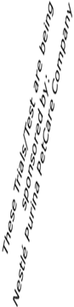

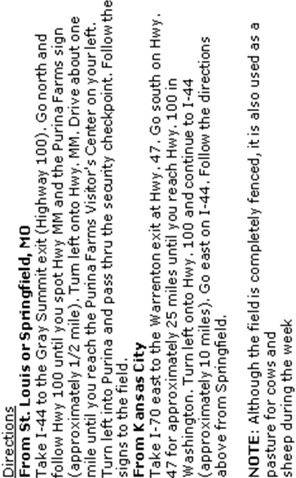

Ibizan Hound Club of the United States
Christine Allen
322 Tooley Branch Road
Westmoreland, TN 37186
DATED MATERIAL


ATTENTION: IBIZAN EXHIBITORS
There will be a group photo taken BETWEEN the AKC and ASFA Trials. This will be for any owner/handler AND dog(s) that are available during the Lure Coursing Trials.
If you want to be in the photo please be at the coursing field 30 minutes before the end of the AKC trial.
Photo will be taken by Ky Boe!


Licensed by the American Kennel Club
PREMIUM LIST
Event #2013291605
JC Test | Qualified Courser Test | Trial
THURSDAY
September 12, 2013


(1) JC Tests (1) QC Test (1) Trial ------Thursday - Sept 12, 2013
Ibizan Hounds ONLY
PURINA FARMS; 200 Checkboard Dr; Gray Summit, MO

Early Entries close 6 p.m. on
Wednesday, August 28th, 2013

Entry Fees
Early entry first hound . . . . . . . ………………. . . . . . . ... $20 per hound
Each additional hound, same owner. . . . . . . . . $18 per hound
Day of trial entry . . . . .. .. . . . . .. . . . . . . . . . . . . $25 per hound
Early entry for Singles Stake………………….……...…….$15 per hound
Day of trial entry ……………………….……….……….$20 per hound
Early entry for J.C.’s and Q.C.’s ……………….……… $15 per hound
Day of trial entry …………..………………….…………$20 per hound

Early entry Breeder, Kennel and Bench Stakes. . .. . $ 5 per entry
Day of trial entry . . . . .. .. . . . . .. . . . . . . . . . . . . $20 per Entry
Early entry Performance Stake . . . . . .. . . . . . . . ... . . . Free
Day of Trial: . . . .. . . . . . . .. . . . . . . . .. .. . . . . . . .. . . $10 per Entry

Phone, fax, and email entries will NOT be accepted.
Entries may be acknowledged by email.
Send entries to: Christine Allen;
322 Tooley Branch Rd; Westmoreland, TN 37186

LICENSED BY THE AMERICAN KENNEL CLUB

Permission has been granted by the American Kennel Club for
the holding of this event under AKC Rules and Regulations.
James Crowley, Secretary
IBIZAN HOUND CLUB OF THE UNITED STATES
Officers
President Lisa McKay; president@ihcus.org
Vice President Robin Castillo
Secretary Linda Boe; 785 Crossland Drive; Grayslake, IL 60030; secretary@ihcus.org
Treasurer Janet Rivers
Board Teddy Burke Carol Kauffman Meegan Pieroti-Tietje Chris Allen

AKC Field Committee
Chairman: Holly Hamilton; 6756 Belkenton Ave; Cincinnati, OH 45236
hollylulu@mac.com 513/793-0329
Secretary: Christine Allen; 322 Tooley Branch Rd; Westmoreland, TN 37186
atairacres@gmail.com 615/406-8220
Other Committee Members: Kristy Stocker, Christy Shaw, Shelley Kozinski, Meagan Pierotti-Tietje Wendy & Kurt Anderson,
and any other club member that is in attendance at the time.
Lure Operator:  Photographer: | Alan Salm  Ky Boe (http://kyboephotography.zenfolio.com/)

Judges and Assignments
Gary T Runyan
AKC Judges #: ZD513
RR 4 BOX 80
SALLISAW, OK 74955-9706
Email: runyanborzoi@yahoo.com

Frances Abrams
AKC Judges #: ZC235
1899 HILT RD
YELLOW SPRINGS, OH 45387-7717
Email: frances.abrams@att.net

EVENT | HOURS | DAY OF TRIAL ENTRIES CLOSE | ROLLING INSPECTION  Begins | START RUNNING
JC Test Judge:  Frances Abrams | 7:30 a.m. until completion | 8:00 a.m. | 8:15 a.m. | 9:00 a.m.
QC Test Judge:  Gary Runyan | 7:30 a.m. until completion | 8:00 a.m. | 8:15 a.m | 15 minutes after the conclusion of JC Test
Trial Judges:  Frances Abrams  Gary Runyan | 7:30 a.m. until completion | 8:30 a.m. | 9:30 a.m. | 10:00 or 15 minutes after the conclusion of QC’s – whichever is later.

Ribbons & Prizes
Trial: Rosettes/Ribbons: First=Blue, Second=Red, Third=Yellow, Fourth=White, Fifth=Pink, Best of Breed=Purple/Gold,
JC Tests: Green Flat Ribbon
Trophies for 1st thru 4th placements

Eligible Breed & Registry
Only Ibizan Hounds, that are one year of age or older, that have been registered with The American Kennel Club, or part of an AKC-registered litter, or otherwise, if whelped outside of the United States of America and owned by a resident of the USA, or of a country with a foreign registry organization whose pedigrees are acceptable for AKC registration and is registered with that registry, or that have been granted an Indefinite Listing Privilege (ILP), are eligible to participate in lure coursing tests and trials. Hounds may not be entered as “registration pending” or “ILP Pending.” Breed disqualifications apply

TESTS & STAKES OFFERED
Test Offered
Junior Courser: Open to eligible Ibizan Hounds. A hound running alone must receive a certification from a Judge on one date, and a second certification from a different Judge at a later date, with each Judge stating that the hound completed a (minimum) 600-yard course with a minimum of 4 turns. The hound must complete the entire course with enthusiasm and without interruption. Ribbons (Dark Green) will be awarded to all hounds that successfully complete the AKC Junior Courser Test.
Qualifying Courser Offered
Qualifying Courser: Open to eligible Ibizan Hounds. The qualifying hound will run with another hound, completing a (minimum) 600-yard course with a minimum of 5 turns. The qualifying hound must complete the entire course with enthusiasm, without interruption, and without coursing, interfering with, or aggressing on the other hound. Owner of qualifying dog must provide or arrange for a hound of like running style for their hound to run with in this test.
Stakes Offered
OPEN: Open only to eligible Ibizan Hounds with no breed disqualifications, that hold an AKC QC certificate OR have run in the Open Stake prior to Jan. 1, 2010, OR have a Senior Courser title OR have an ASFA or CKC field champion title. (a copy of this title must be attached to the entry form if the QC requirement is to be waived). Championship points are awarded from this stake.

OPEN VETERAN: Open only to Ibizan Hounds that are eligible to enter either Open or Special Stake, and are of Veteran age (6 years of age and older). Championship or LCX points may be awarded from this stake.

SPECIAL: Open only to Ibizan Hounds that are eligible to enter the Open Stake and have earned their AKC Field Championship title. LCX points may be awarded from this stake. Hounds under disqualification from AKC, ASFA or CKC Field Trials may NOT be entered.

SINGLES: Open only to Ibizan Hounds. Hounds with breed disqualifications are eligible to enter. Hounds entered in the Singles Stake shall not be allowed to enter the regular stakes. Each hound will be run individually. LIMIT to 10 Hounds!

NON-REGULARY STAKES:***

BREEDER STAKE: For two Ibizan Hounds, designated at time of entry, bred by the same
individual.

KENNEL STAKE: For two Ibizan Hounds, designated at time of entry, owned and kenneled by the same individual

BENCH CHAMPION: For any hound eligible to enter a regular stake, that is an AKC, CKC, UKC or ASFA-approved International show champion of record. A copy of the hound's championship certificate must accompany each entry.

PERFORMANCE TITLED: For any hound eligible to enter a regular stake, that is an AKC, CKC or UKC performance title holder of record (excluding Field Trial Titles). A copy of the hound's title certificate must accompany each entry.
***If a tie exists after the final runs then the dog(s) with the highest FINAL score will be declared the winner. IF the final score is tied then the dog(s) with the highest Preliminary score will be declared the winner.
CHALLENGE TROPHY

The Scotty Challenge Trophy – an Ibizan Hound portrait hand painted on Agate by artist Mary Delmoro offered by Judy Umeck in memory of Ch. Luxor's Smotare Buckaroo Banzai, JC, to be awarded for Best of Breed at the AKC Ibizan Hound Club of the United States National Lure Coursing Trial.
For permanent possession: BOB must be won three times by the same owner, not necessarily with the same dog, nor at consecutive trials. The trophy will remain in the possession of IHCUS until retired.
Best of Breed  THANK YOU TO ALL OF THE INDIVIDUALS THAT DONATED TROPHIES TO MAKE THIS EVENT SPECIAL! | Sponsored by Altamira Ibizan Hounds
High Scoring Open | Sarah Murphy, Abbaio Ibizan Hounds
High Scoring Special | Sarah Murphy, Abbaio Ibizan Hounds
Limited Stake | Louie Boe
High Scoring Breeder Stake | HareHill Hounds
High Scoring Kennel Stake | Team Sweetwater
High Scoring CH of Record | Notanuff Ibizans
High Scoring Perfomance Title (does not include FC or FCh) | Jennifer Anderson
Open Stake A    ATTENTION: IBIZAN EXHIBITORS  There will be a group photo taken BETWEEN the AKC and ASFA Trials. This will be for any owner/handler AND dog(s) that are available during the Lure Coursing Trials.  If you want to be in the photo please be at the coursing field 30 minutes before the end of the AKC trial.  Photo will be taken by Ky Boe!   | Teddy Burke, Arbeca Ibizan Hounds
Open Stake B | Redfaire Ibizan Hounds
Open Stake C | Courtenay Nester
Special Stake A | Redfaire Ibizan Hounds
Special Stake B | Mandy Kleiman
Special Stake C | Ella Boe
Veteran Stakes Includes High Scoring Veteran | Sponsored by Patricia First  “The Hounds of Aigh”

Class Winners and Best Of Breed will also be

Sponsored by Purina

All Purina prizes, if not awarded at the trials must be picked up during the event at the Purina booth. Presentation of the winning ribbon or Purina certificate is required.

Purina reserves the right to make prize substitutions of equal or greater value in the event a specific listed prize is not available.
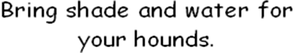
Veterinarian on Call:
Pacific Animal Hospital; 450 Flier Dr.; Pacific, MO 63069
636-257-2100
24-hour emergency services available

Conditions of Entry
• All entries must be one year of age or older on the day of the trial.
• Hounds not present at the time of roll call will be scratched after a 5 minute grace period and no refund will be given.
• Stakes may be split if sufficient entries are present in any one stake at the time of the draw to support more than one 5-point Major.
• Bitches in season and lame hounds will be excused. Entries will be refunded. These are the only reasons that Early Entries will be refunded after the pre-entry closing date.
• There will be a minimum $30 returned check charge.
• Hounds will be checked for breed disqualifications. Spayed and neutered hounds are eligible to participate. Monorchid and cryptorchid hounds are ineligible to participate.
• Owners of hounds entered for a QC run are responsible for providing and/or arranging for the additional hound to run with.
• A $5.00 fine will be assessed for any loose hound on the field that is not competing in the course in progress.
• Battery powered, continuous loop equipment will be used. Lures consist of white plastic.
• Back-up equipment will be available.
• IHCUS reserves the right to alter course due to field and/or weather conditions on the day of the trial.
• Course will be reversed for finals, run-offs and BOB.
- Although the field is completely fenced, it is also used as a pasture for cows and sheep during the week
- Adequate shade and cool/drinking water should be provided by the participants.
.• Any person may, upon reasonable complaint, be asked to leave the grounds by the Field Committee. Children MUST be under control of their parents or guardians at all times.

Only the Lure Operator, Huntmaster, Judges and Handlers of the hounds running in the course in progress will be permitted near the lure machine.

How to enter your dog and earn AKC Titles

- Your dog must first earn a Qualifying Courser (QC) certification. Be sure to CHECK OFF “QC” ON THE ENTRY FORM.
- Next, if your dog has practiced successfully with other dogs (not interfering either aggressively OR playfully), you should enter him in Open and work towards the Senior Courser (SC) title. If your dog also wins a placement he will earn points towards his Field Championship (see point scale below). CHECK “OPEN” ON THE ENTRY FORM, AND PAY THE ENTRY FEE FOR OPEN. There is no additional fee for the SC leg. To earn the SC title, the hound must run with at least one other hound, and must receive qualifying scores at FOUR (4) AKC trials under two different judges or judging panels.
- When your dog has earned the SC title, he most likely will still be competing for Field Championship points. If he receives qualifying scores in 25 trials, he will earn the Master Courser (MC) title.
- The title of Field Champion (FC) is a prefix to a hound’s name. It is earned by obtaining 15 points from the Open or Veteran stakes. Dog must win 2 first placements worth 3 or more points under two different judges or judging panels (majors).
- A dog who has earned his Field Championship title must be entered in the Special Stake.

SCHEDULE OF POINTS BY BREED FOR FIRST PLACE
POINTS | 1pt | 2pts | 3pts | 4pts | 5pts
IB Entry | 2 | 3 | 4 | 5 | 6
.
 | Major
1st place earns | 5 pts | 4 pts | 3 pts
2nd place earns | 3 pts | 2 pts | 1 pts
3rd place earns | 2 pts | 1 pts | 0 pts

Notes for the weekend:
  - If you have ANY questions about what stakes/tests to enter your dog, e-mail the field trial secretary.

  - Box Lunches will be available if pre-ordered.

  - Make sure to bring shade and water for your hounds

  - All hounds finishing their QC titles are eligible to run in Open BUT IT IS ONLY ENCOURAGED if they’ve run more than just the QC with another hound, and have run cleanly without coursing another hound or interfering in any way

  - Your hound no longer needs a JC to enter a trial but the JC still appears as a title after your hounds name if they earn it.

  - There will be a port-a-john on site.

  - Please park in the parking lot located prior to the bridge

  - Make sure to pay attention to the running order, your dog’s colors, and to the paddock master – if your hound is ready and waiting, when it’s his turn to run, the trial goes smoother for everyone. Any hound that is more than five minutes late in getting to the line for their course may be excused from competition for the day as per AKC rules.

  - If you are new to the sport, grab someone and ask questions! We’re always happy to help “newbies” learn the ropes!

  - Anybody exhibiting unsportsmanlike behavior will be excused from the field and may be subject to further disciplinary action.

  - No cigarette smoking on or near the field.

Course plan for JC and QC

700 Yards

(Reversed for QC’s)
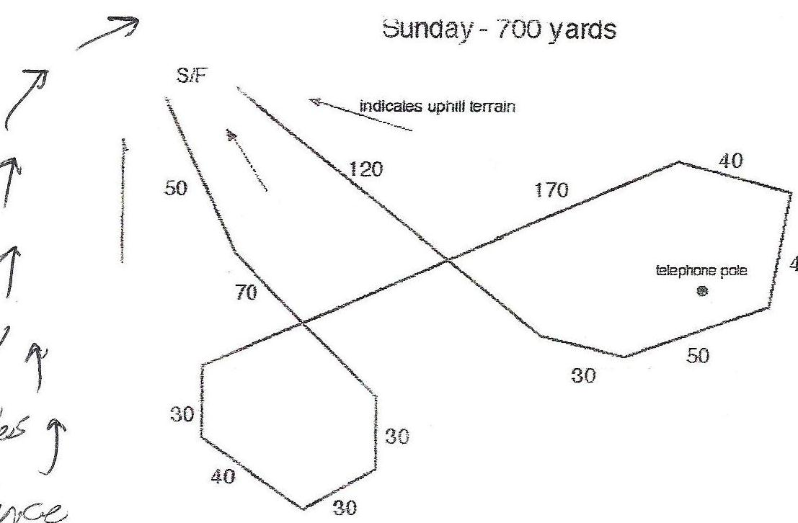

Course plan for Trial

790 Yards

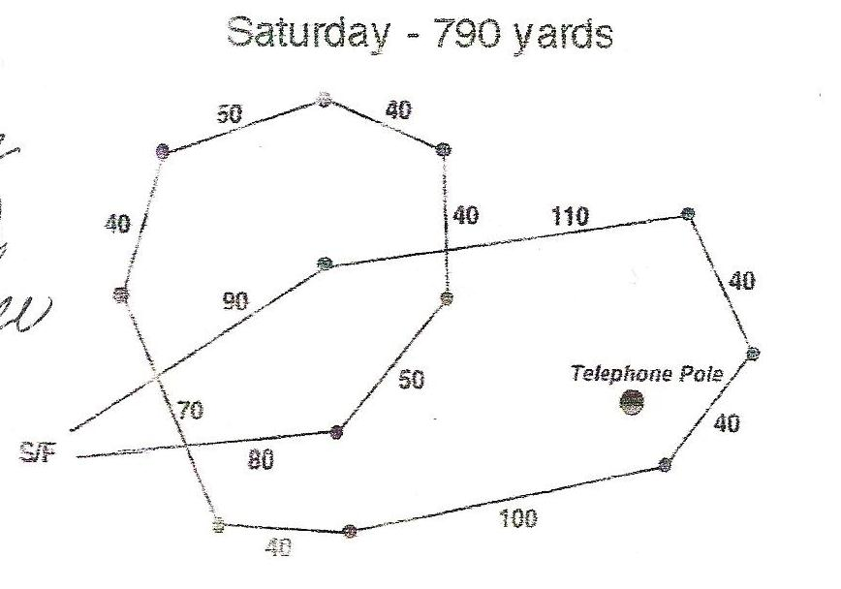
(Reversed for finals)

ADDITIONAL NOTES ABOUT QC RUNS

- All dogs entering the Open stake must now earn a Qualifying Courser certification. (Unless said hound has run in the open or open veteran stake in a trial prior to Jan. 1. 2010 or holds a field champion title from ASFA or CKC – a copy of such title needs to accompany the hounds first trial entry)

- You are responsible for finding a hound of like running style to run your QC hound with. You can not expect to run your hound for a QC without arranging for another hound to help certify yours.

- You will be handed a form to fill out at roll call. You must fill this out and RETURN it to the Field Trial Secretary BEFORE the QC runs begin – THIS IS IMPORTANT!

- Once your hound has completed it’s QC and the judge has come off the field, please see the Field Trial Secretary to retrieve your certification form. You will need to attach this (or a copy of it) to your hounds first official entry into the Open or Open Veteran stake.

- The JC test is no longer required AT ALL to enter the open stake and, in fact, a hound may have a JC title but without the QC (or other stated requirements) a hound MAY NOT enter the Open or Open Veteran stake at a trial.

- If you have any questions about this – please contact your Field Trial Secretary

- This weekend we will be running ALL JC’s, then QC’s, then the TRIAL. Dogs that have earned their QC may enter the Trial by paying DOS entry fees and entering prior to DOS closing time

Box Lunches will be available if pre-ordered.
Pre-Order form available on IHCUS website:
http://www.ihcus.org/specialty/2013-national-specialty

Accommodations:

Holiday Inn Six Flags 4901 Allenton Road, Eureka, MO (636) 938-6661 (Host Hotel)

The Diamond Inn I-44 and Hwy. 100, Gray Summit, MO (636) 742-3501

EconoLodge Eureka 1725 W. 5th St., Eureka, MO (636)938-5348 or (800)251-1962

Super 8 Eureka 1733 W. 5th St., Eureka, MO (636) 938-4368, or (800) 800-8000

Budget Lodging 866 S. Outer Rd., St. Clair, MO (636) 629-1000 or (800) 958-4354

Super 8 St. Clair 1010 S Outer Rd, St. Clair, MO (636)629-8080 or (800)800-8000

Drury Inn 1088 S. Highway Dr., Fenton, MO (636) 343-7822 or (800) 378-7946

Pear Tree Inn 100 S. Highway Dr., Fenton, MO (636- 343-8820 or (800) 378-7946

KOA St. Louis West 18475 Old Highway 66, Eureka, MO (636) 257-3018

PLEASE VERIFY CURRENT PET POLICIES WHEN MAKING RESERVATIONS

THERE IS ABSOLUTELY NO CAMPING PERMITTED AT THE TRIAL SITE

ATTENTION: IBIZAN EXHIBITORS
There will be a group photo taken BETWEEN the AKC and ASFA Trials. This will be for any owner/handler AND dog(s) that are available during the Lure Coursing Trials.
If you want to be in the photo please be at the coursing field 30 minutes before the end of the AKC trial.
Photo will be taken by Ky Boe!


Camping is available at the Purina Show grounds.

Forms available on IHCUS website:

(http://www.ihcus.org/specialty/2013-national-specialty).




official entry form for lure coursing

Date: Sept 12, 2013

Club name: IBIZAN HOUND CLUB OF THE US

(IMPORTANT: carefully read instructions on bottom before filling out)
breed  Ibizan Hound |  | sex: Male  Female |  |  | Event Number
Test: JC QC TRIAL: SINGLES OPEN SPECIALS VETERAN
Location Grey Summit, Mo / Purina Farms |  |  | Event Type (Check one) Test Trial
akc® name (Include AKC titles only) |  |  |  |  |  | call name of dog
akc® no. ilp  pal foreign reg. no | (Enter number below) |  |  | date of birth  place of birth (List Country)
breeder
sire
dam
actual owners
owners address |  |  | new address
city, state, zip + 4 , -
AKC Rules, Regulations, Policies and Guidelines are available on the American Kennel Club website:www.akc.org
AGREEMENT
I certify that I am the actual owner of the dog, or that I am the duly authorized agent of the actual owner whose name I have entered above. In consideration of the acceptance of this entry, I (we) agree to abide by the rules and regulations of The American Kennel Club in effect at the time of this event, and any additional rules and regulations appearing in the premium list of this event and entry form and any decision made in accord with them. I (we) agree that the club holding this event has the right to refuse this entry for cause which the club shall deem sufficient. In consideration of the acceptance of this entry and of the holding of this event and of the opportunity to have the dog judged and to win prizes, ribbons, or trophies, I (we) agree to hold the AKC, the event-giving club, their members, directors, governors, officers, agents, superintendents or event secretary and the owner and/or lessor of the premises and any provider of services that are necessary to hold this event and any employees or volunteers of the aforementioned parties, and any AKC approved judge, judging at this event, harmless from any claim for loss or injury which may be alleged to have been caused directly or indirectly to any person or thing by the act of this dog while in or about the event premises or grounds or near any entrance thereto, and I (we) personally assume all responsibility and liability for any such claim; and I (we) further agree to hold the aforementioned parties harmless from any claim for loss, injury or damage to this dog. Additionally, I (we) hereby assume the sole responsibility for and agree to indemnify, defend and save the aforementioned parties harmless from any and all loss and expense (including legal fees) by reason of the liability imposed by law upon any of the fore mentioned parties for damage because of bodily injuries, including death at any time resulting there from, sustained by any person or persons, including myself (ourselves), or on account of damage to property, arising out of or in consequence of my (our) participation in this event, however such, injuries, death or property damage may be caused, and whether or not the same may have been caused or may be alleged to have been caused by the negligence of the aforementioned parties or any of their employees, agents, or any other persons. I (WE) AGREE THAT ANY CAUSE OF ACTION, CONTROVERSY OR CLAIM ARISING OUT OF OR RELATED TO THE ENTRY, EXHIBITION OR ATTENDANCE AT THE EVENT BETWEEN THE AKC AND THE EVENTGIVING CLUB (UNLESS OTHERWISE STATED IN TIS PREMIUM LIST) AND MYSELF (OURSELVES) OR AS TO THE CONSTRUCTION, INTERPRETATION AND EFFECT OF THIS AGREEMENT SHALL BE SETTLED BY ARBITRATION PURSUANT TO THE APPLICABLE RULES OF THE AMERICAN ARBITRATION ASSOCIATION. HOWEVER, PRIOR TO ARBITRATION ALL APPLICABLE AKC BYLAWS, RULES, REGULATIONS AND PROCEDURES MUST FIRST BE FOLLOWED AS SET FORTH IN THE AKC CHARTER AND BYLAWS, RULES, REGULATIONS, PUBLISHED POLICIES AND GUIDELINES.
Name of Owner’s Agent/handler (if any) at Trial |  | fee enclosed
Phone Number:  / - | e-mail address:  @ .
Bench Stake Performance Stake Kennel Stake w/______ Breeder Stake w/ _____
AEAGLC2 - (06/11)
official entry form for lure coursing

Date: Sept 12, 2013

Club name: IBIZAN HOUND CLUB OF THE US

(IMPORTANT: carefully read instructions on bottom before filling out)
breed  Ibizan Hound |  | sex: Male  Female |  |  | Event Number
Test: JC QC TRIAL: SINGLES OPEN SPECIALS VETERAN
Location Grey Summit, Mo / Purina Farms |  |  | Event Type (Check one) Test Trial
akc® name (Include AKC titles only) |  |  |  |  |  | call name of dog
akc® no. ilp  pal foreign reg. no | (Enter number below) |  |  | date of birth  place of birth (List Country)
breeder
sire
dam
actual owners
owners address |  |  | new address
city, state, zip + 4 , -
AKC Rules, Regulations, Policies and Guidelines are available on the American Kennel Club website:www.akc.org
AGREEMENT
I certify that I am the actual owner of the dog, or that I am the duly authorized agent of the actual owner whose name I have entered above. In consideration of the acceptance of this entry, I (we) agree to abide by the rules and regulations of The American Kennel Club in effect at the time of this event, and any additional rules and regulations appearing in the premium list of this event and entry form and any decision made in accord with them. I (we) agree that the club holding this event has the right to refuse this entry for cause which the club shall deem sufficient. In consideration of the acceptance of this entry and of the holding of this event and of the opportunity to have the dog judged and to win prizes, ribbons, or trophies, I (we) agree to hold the AKC, the event-giving club, their members, directors, governors, officers, agents, superintendents or event secretary and the owner and/or lessor of the premises and any provider of services that are necessary to hold this event and any employees or volunteers of the aforementioned parties, and any AKC approved judge, judging at this event, harmless from any claim for loss or injury which may be alleged to have been caused directly or indirectly to any person or thing by the act of this dog while in or about the event premises or grounds or near any entrance thereto, and I (we) personally assume all responsibility and liability for any such claim; and I (we) further agree to hold the aforementioned parties harmless from any claim for loss, injury or damage to this dog. Additionally, I (we) hereby assume the sole responsibility for and agree to indemnify, defend and save the aforementioned parties harmless from any and all loss and expense (including legal fees) by reason of the liability imposed by law upon any of the fore mentioned parties for damage because of bodily injuries, including death at any time resulting there from, sustained by any person or persons, including myself (ourselves), or on account of damage to property, arising out of or in consequence of my (our) participation in this event, however such, injuries, death or property damage may be caused, and whether or not the same may have been caused or may be alleged to have been caused by the negligence of the aforementioned parties or any of their employees, agents, or any other persons. I (WE) AGREE THAT ANY CAUSE OF ACTION, CONTROVERSY OR CLAIM ARISING OUT OF OR RELATED TO THE ENTRY, EXHIBITION OR ATTENDANCE AT THE EVENT BETWEEN THE AKC AND THE EVENTGIVING CLUB (UNLESS OTHERWISE STATED IN TIS PREMIUM LIST) AND MYSELF (OURSELVES) OR AS TO THE CONSTRUCTION, INTERPRETATION AND EFFECT OF THIS AGREEMENT SHALL BE SETTLED BY ARBITRATION PURSUANT TO THE APPLICABLE RULES OF THE AMERICAN ARBITRATION ASSOCIATION. HOWEVER, PRIOR TO ARBITRATION ALL APPLICABLE AKC BYLAWS, RULES, REGULATIONS AND PROCEDURES MUST FIRST BE FOLLOWED AS SET FORTH IN THE AKC CHARTER AND BYLAWS, RULES, REGULATIONS, PUBLISHED POLICIES AND GUIDELINES.
Name of Owner’s Agent/handler (if any) at Trial |  | fee enclosed
Phone Number:  / - | e-mail address:  @ .
Bench Stake Performance Stake Kennel Stake w/_____ Breeder Stake w/ ____
AEAGLC2 - (06/11)
.FILL OUT ENTRY/ENTRIES BELOW FOR KENNEL STAKES.
$5 Charge for Kennel entry (2 dogs = 1 entry)
DOS Entry into Kennel Stakes will be $20 per entry

KENNEL STAKE ENTRY
Call Name -- Registered Name --- Registration Number

Hound 1:
Call Name:
..........................................................................................................
Registered Name:
..........................................................................................................

Registration Number:
..........................................................................................................

Hound 2:
Call Name:
..........................................................................................................
Registered Name:
..........................................................................................................
Registration Number:
..........................................................................................................
Name of Owner:
..........................................................................................................

FILL OUT ENTRY/ENTRIES BELOW FOR KENNEL/BREEDER STAKES.
$5 Charge for Kennel and/or Breeder Stake entry (2 dogs = 1 entry)
DOS Entry into Kennel Stakes will be $20 per entry

KENNEL STAKE ENTRY
Call Name -- Registered Name --- Registration Number

Hound 3:
Call Name:
..........................................................................................................
Registered Name:
..........................................................................................................

Registration Number:
..........................................................................................................

Hound 4:
Call Name:
..........................................................................................................
Registered Name:
..........................................................................................................
Registration Number:
..........................................................................................................
Name of Owner:
FILL OUT ENTRY/ENTRIES BELOW FOR BREEDER STAKES.
$5 Charge for Breeder Stake entry (2 dogs = 1 entry)
DOS Entry into Breeder Stakes will be $20 per entry

BREEDER STAKE ENTRY
Call Name -- Registered Name --- Registration Number

Hound 1:
Call Name:
..........................................................................................................
Registered Name:
..........................................................................................................

Registration Number:
..........................................................................................................

Hound 2:
Call Name:
..........................................................................................................
Registered Name:
..........................................................................................................
Registration Number:
..........................................................................................................
Name of Breeder:
..........................................................................................................

FILL OUT ENTRY/ENTRIES BELOW FOR BREEDER STAKES.
$5 Charge for Breeder Stake entry (2 dogs = 1 entry)
DOS Entry into Kennel Stakes will be $20 per entry

BREEDER STAKE ENTRY
Call Name -- Registered Name --- Registration Number

Hound 3:
Call Name:
..........................................................................................................
Registered Name:
..........................................................................................................

Registration Number:
..........................................................................................................

Hound 4:
Call Name:
..........................................................................................................
Registered Name:
..........................................................................................................
Registration Number:
..........................................................................................................
Name of Breeder:
..........................................................................................................

FILL OUT ENTRY/ENTRIES BELOW FOR BENCH STAKE
$5 Pre-Entry Charge for Bench Stake entry
DOS Entry into Bench Stake will be $20 per entry

BENCH STAKE ENTRY

Call Name -- Registered Name --- Registration Number

Call Name:
..........................................................................................................

Registered Name:
..........................................................................................................

Registration Number:
..........................................................................................................

Owner:
..........................................................................................................

Championship Certificate attached:

BENCH STAKE ENTRY

Call Name -- Registered Name --- Registration Number

Call Name:
..........................................................................................................

Registered Name:
..........................................................................................................

Registration Number:
..........................................................................................................

Owner:
..........................................................................................................

Championship Certificate attached:

FILL OUT ENTRY/ENTRIES BELOW FOR PERFORMANCE STAKE
$0 Pre-Entry Charge for Performance Stake entry
DOS Entry into Performance Stake will be $10 per entry

PERFORMANCE STAKE ENTRY

Call Name -- Registered Name --- Registration Number

Call Name:
..........................................................................................................

Registered Name:
..........................................................................................................

Registration Number:
..........................................................................................................

Owner:
..........................................................................................................

Performance Certificate attached:

PERFORMANCE STAKE ENTRY

Call Name -- Registered Name --- Registration Number

Call Name:
..........................................................................................................

Registered Name:
..........................................................................................................

Registration Number:
..........................................................................................................

Owner:
..........................................................................................................

Performance Certificate attached:

