Ibizan Hound Identification
The Ibizan’s clean-cut lines, large prick ears and light pigment give it a unique appearance.
They are long-legged, lean and sleek hounds.
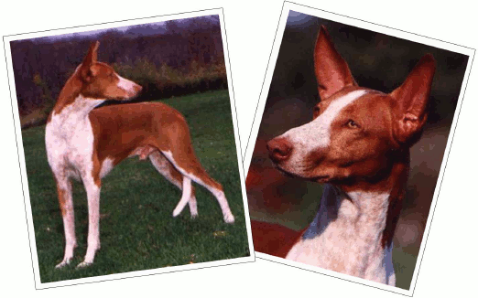
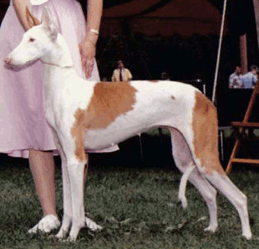
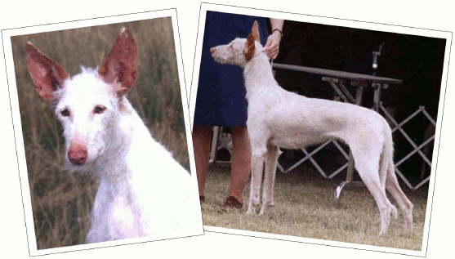
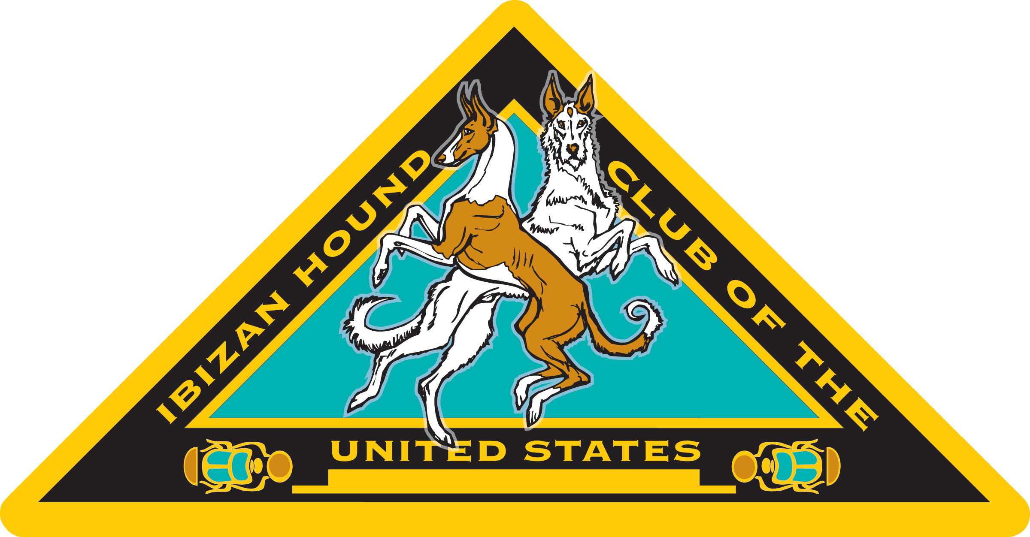
Contact Information
(Breed Rescue)
Michelle Barlak
email: rescue@ihcus.org
website: www.ihcus.org
- Coat can be smooth or wire
- Color is red or white, solid, or in any combination
- Eyes are amber
(light golden brown)
- Nose is pink to light brown
Red & White - Smooth Coat
Pinto Markings
Smooth Coat
White (with red) - Wire Coat
Long Tail
Ears are big and upright

